DBMS Week – 6
SATLAS ROHIT B
2024503305
SELECT & AGGREGATE FUNCTIONS
1. Employees who HAVE a supervisor
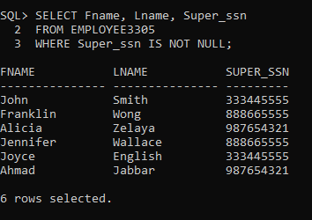

2. Employees with middle initial
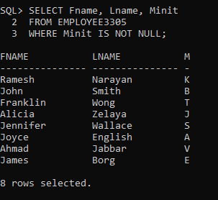

3. Count total number of employees
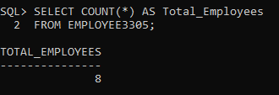

4. Highest and lowest salaries
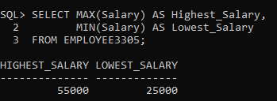

5. Count employees per department
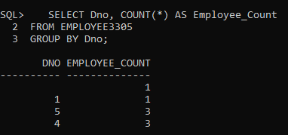

6. Min and max salary per department
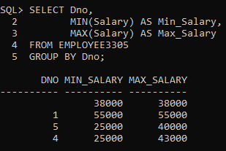

7. Count male and female employees
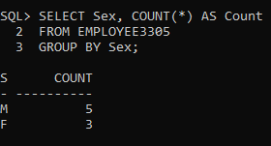

8. Total hours worked per project
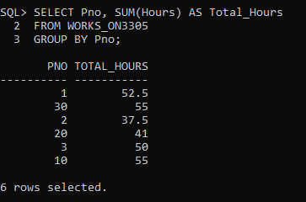

9. Departments with more than 2 employees
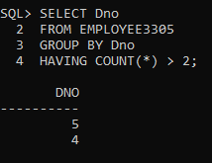

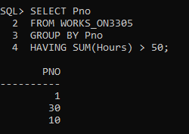
10. Projects with total hours > 50

11. Employees with more than 1 dependent
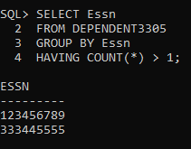

12. Convert names to uppercase
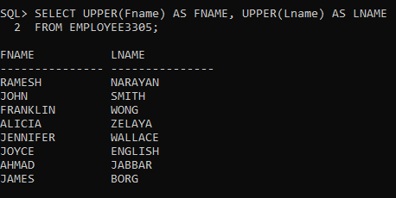

13. Extract city from address
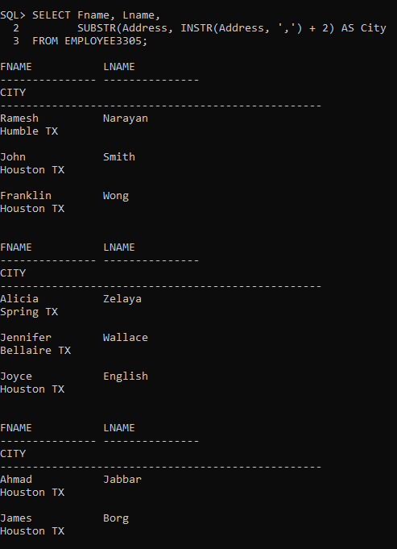

14. Calculate employee age
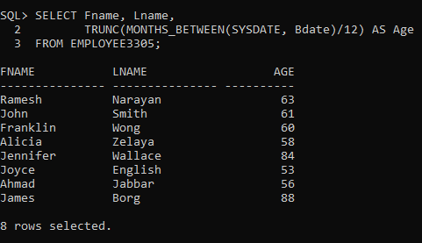

15. Employees born in year 1970
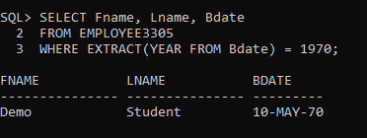

SUBQUERY QUESTIONS
1.Employees earning more than average salary
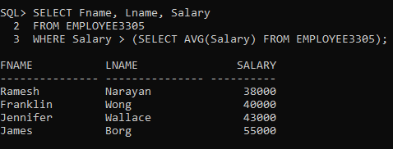

2.Employees working in departments located in Houston
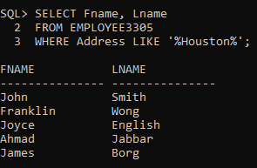

3.Employees with at least one dependent
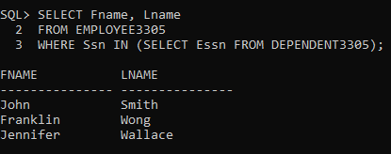

4.Departments with more than 3 employees
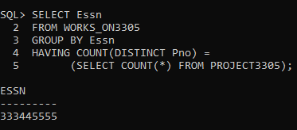

5.Employees who work on ALL projects
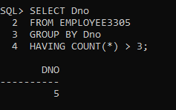

6.Projects with no assigned employees
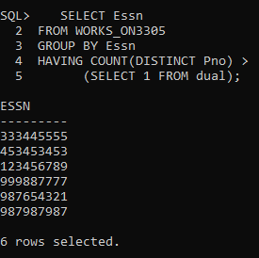

7.Departments with no employees
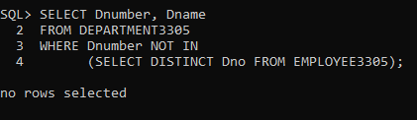

8.Employees who earn more than the minimum salary
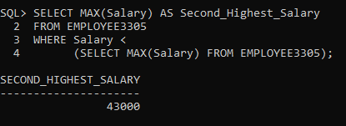

9.Calculate age of each employee
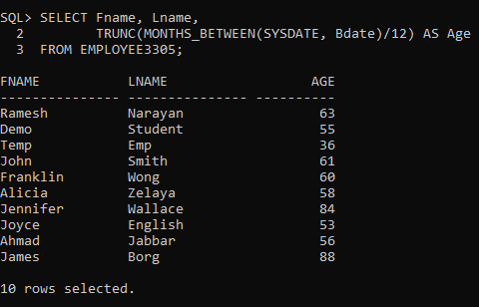

10. Find employees with more dependents than average
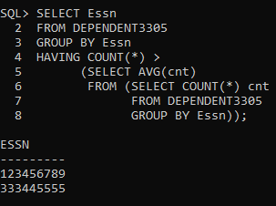

11. Find employees working on ALL projects
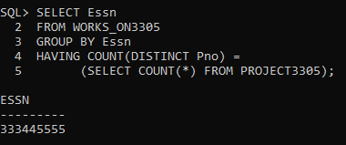

12. Find department with highest average salary
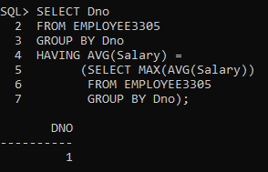

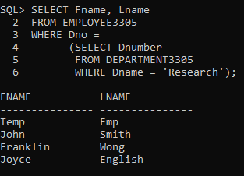
13. Find employees in Research department

